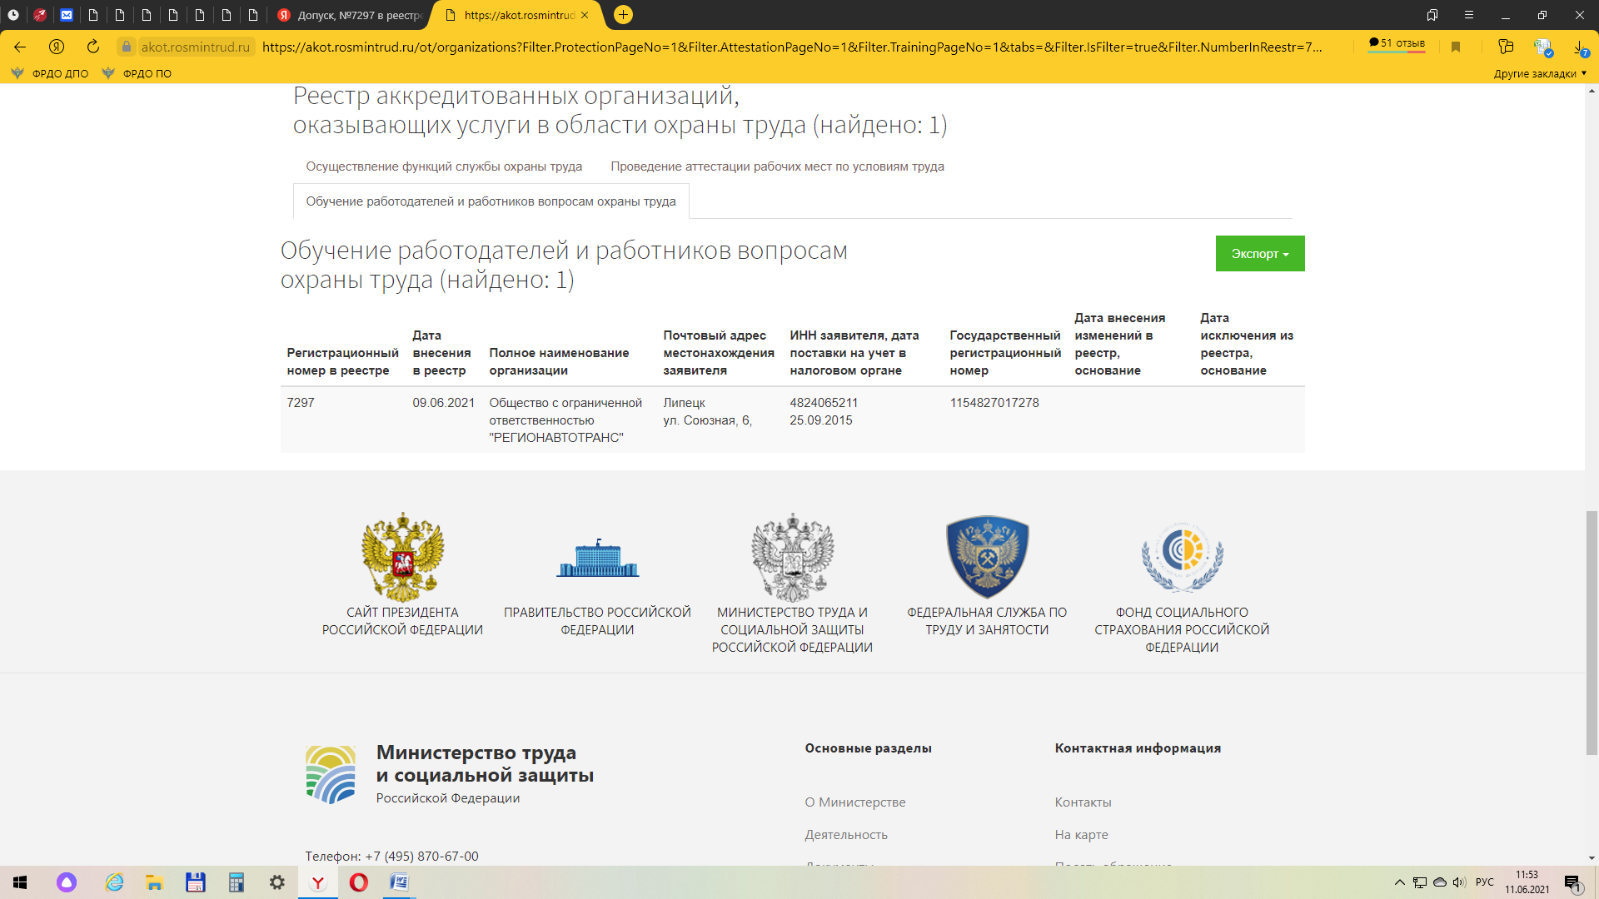

https://akot.rosmintrud.ru/ot/organizations?Filter.ProtectionPageNo=1&Filter.AttestationPageNo=1&Filter.TrainingPageNo=1&tabs=&Filter.IsFilter=true&Filter.NumberInReestr=7297&Filter.Text=&Filter.INN=4824065211&Filter.OGRN=&Filter.OrganizationStatusIds=2&Filter.OrganizationStatusIds=5&Filter.OrganizationOPFId=&Filter.RegionId=&Filter.Address=&Filter.IsReestrSout=0&DateReestrFrom=&DateReestrTo=&DateEditFrom=&DateEditTo=&DateExcludeFrom=&DateExcludeTo=#findForm

